APPEL À COMMUNICATION

Document à retourner avant le mardi 15 mars 2022
Deadline for papers submission: Tuesday 15th March 2022
>> contact@clp-laser.fr <<

Société Company : ……………………………………..…………………………………………………………………………..……………………………………………
Membre CLP CLP Membership | Non-Membre CLP Non-CLP Membership
AILU and LIA members : please contact us.

Conférencier Speaker :
NOM, Prénom NAME, Surname : ………………………………………………………………………….……………….….…...……………….
Fonction Position : …………………………………………………………………………….…………………………….………………………….……
E-mail Email : …………………………………..………………………………………………….………………………….……………...……………….
Téléphone Phone : …………………..………………..……..…………………….……………..……………………………..…………………………

Thème choisi Chosen topic :

Ingénierie de surface Surface engineering Soudage Welding
Design Design Fabrication additive Additive manufacturing
Décoration Decoration Micro-usinage Micro-machining

Temps de parole : 15 min + 5 min de questions Duration : 15 min + 5 min for questions

Vous pouvez présenter votre conférence en français ou en anglais. You may present your conference in French or in English.

Titre en français Title in French : …………………………………………………………………………………………………..………………………………..………….………………………………………
…………………………………………………………………………………………………..………………………………..………….………………………………………
Titre en anglais Title in English :
…………………………………………………………………………………………………..………………………………..………….………………………………………
…………………………………………………………………………………………………..………………………………..………….………………………………………

Co-auteurs co-authors :
(1) Nom, Prénom, Email : …………………………………………………………………………………………………..………………………………..…………
(2) Nom, Prénom, Email : …………………………………………………………………………………………………..………………………………..…………
(3) Nom, Prénom, Email : …………………………………………………………………………………………………..………………………………..…………
(4) Nom, Prénom, Email : …………………………………………………………………………………………………..………………………………..…………

MERCI DE JOINDRE VOTRE RÉSUMÉ (template page suivante)
Please join your extended abstract (see template below)
Merci de répondre à l’appel au plus tôt !
Please answer the call as soon as possible!

Paper title with all lowercase letters except for the first letter, abbreviations, chemical formulae, and proper nouns in Paper–Title style

First Author^{1,2}, Second Author^{1–3}, Third Author*³, Forth Author² (in Paper–Author style)

1-The First Affiliation, Country (in Paper - Affiliation style.)
2-The Second Affiliation, Country (Shift-Enter to go down a new line, but a new paragraph)
3-Department of Laser, The Third Affiliation, Country
*corresponding.author@email.address

Use Paper–Paragraph style for paragraphs. Upon your submission, you are asked to agree with the Privacy Policy of Club Laser & Procédés and Micronora, and with that authors’ names, affiliations, countries, and abstract title (presentation attributes), will be indicated on the advance and final program to be shown on the CLP website, and with that the presentation attributes and abstract content will be published on the conference proceedings. Program Committee will review all the submitted abstracts.

The abstract must be written in English. There will be no formatting done to the abstract prior to publication in the abstract book. Therefore, it is very important for you to ensure that your abstract follows the style guidelines presented in this template in order to provide a uniform and consistent appearance. Abstract should not exceed one page in length. The dimension of the paper is A4 size paper: 210 mm x 297 mm. Margins should be 25.4 mm on all sides, and the text should be written in 10 point Calibri. In case your abstract is too short, you will be asked to modify it with more texts and/or figures. The abstract must be submitted in a WORD and PDF format. The quality of figures should be clear enough. The size of the PDF file should not exceed 6 MB. Use the styles predefined in the template file. It is highly recommended to use Calibri font throughout the abstract file. A couple of Figures/Tables may be included to the abstract. Large figures should be centred as shown in the Figure 1, and small ones may be placed side by side. In all cases, the figures must be located completely inside the paper margins. Figure and Table captions, in 9 pt, should be positioned in centre below the figures as shown in Figure 1.

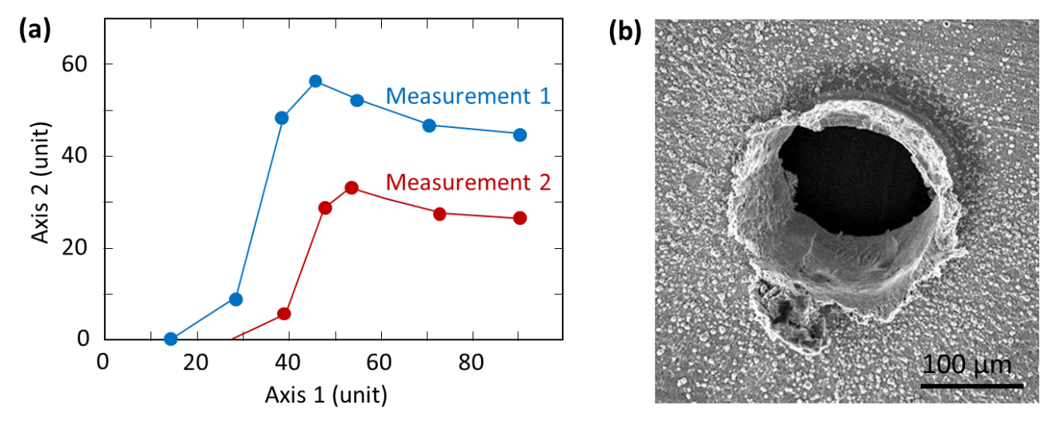
Figure 1 (a) The figure, as well as each axis coordinates and titles must be large enough to be easily read. (b) Any micrographs being used should have a scalebar and good contrast in order to ensure proper visibility. The font of text in the figures should be Calibri.

All references should be numbered and appear at the end of the abstract in the same order as used in the text. The font should be the same as the main body of the text but with an 9 point size. Reference should be aligned to the left. In the main body of the text, the reference designation should be with square brackets [1], and several references can be included together using a comma [2, 3]. If three or more consecutive references occur together, a dash is to be used [1-3].

[1] A. Author and B. Author, Title of paper, Journal Name, vol., pp. start page-end page, (year)
[2] A. Author, B. Author, and C. Author, Title of paper, Journal Name, vol., pp. start-end, (year)
[3] A. Author, Title of book (Publisher), Chapter, (year)

